**– Sample Application**

Table of Contents

**1.** **Introduction** 3

**2.** **Screen View** 3

**2.1** **Home Page** 3

**2.2** **Add list** 4

**2.3** **Blank list page** 4

**2.4** **Card model** 4

**2.5** **List with task** 5

**2.6** **Confirmation Delete model for card** 5

**2.7** **Confirmation Delete model for list** 6

**3.** **Approach** 7

# **Introduction**

This sample application involves in creation of dynamic task list and user can add, edit, delete, task on list also can drag drop list items from one to another and can drag drop whole list. Below is the flow diagram of application.

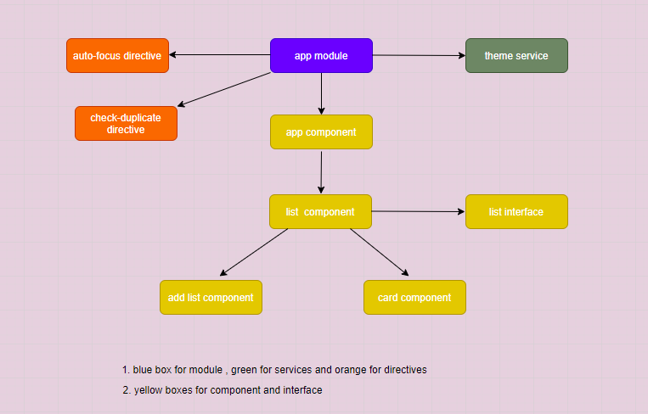

*Figure 1: Architecture for Sample Application*

# **Screen View**

# **Home Page**

On home screen you will get title, radio buttons for theme and add list button to add list

*Figure 2: home screen*

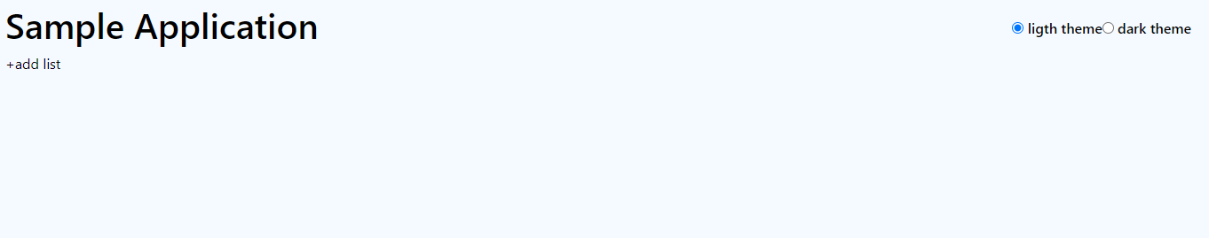

# **Add list**

After clicking add list you get model for adding list

*Figure 3 : Add list model*

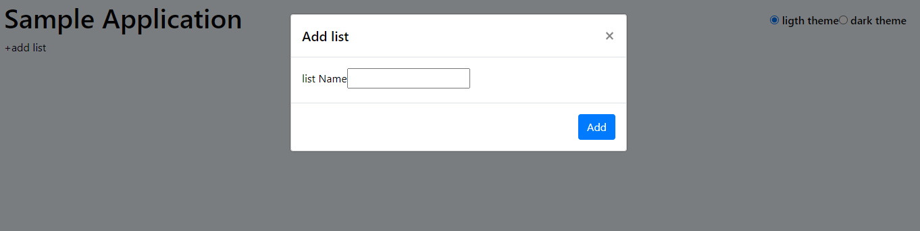

# **Blank list page**

After adding list we will get blank list box

*Figure 4(a): bland list box*

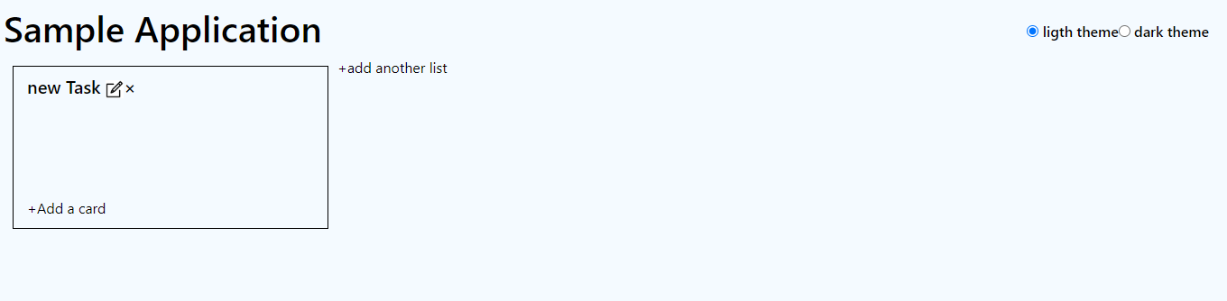

*Figure 4(b): multiple bland list box*

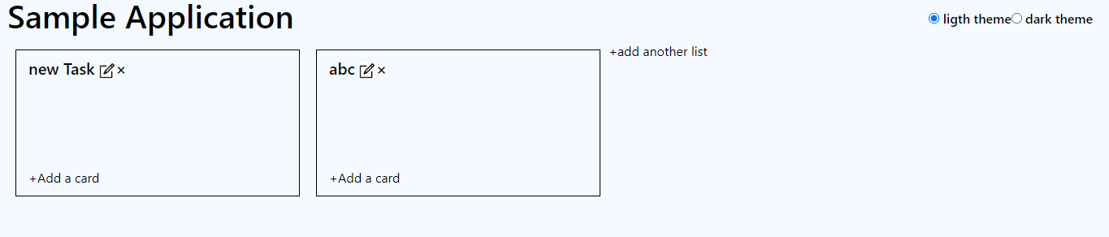

# **Card model**

On clicking add a card button card model will open.

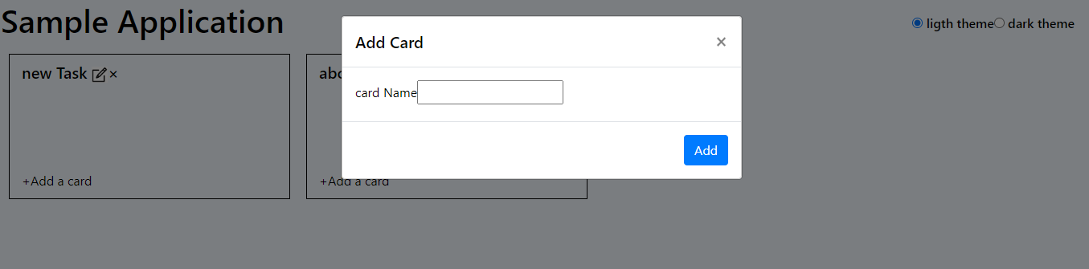

*Figure 5: Card Model*

# **List with task**

After clicking add button on add card model task is added to list

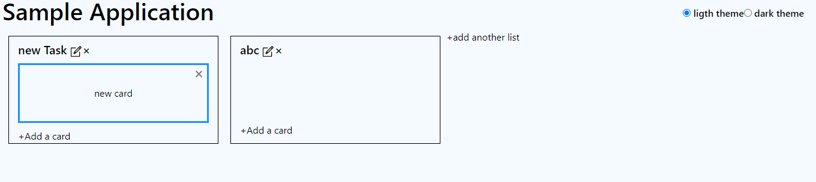

*Figure 6(a): list with task*

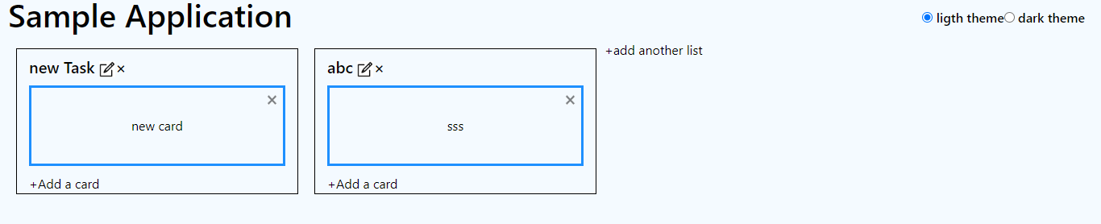

*Figure 6(b): list with task added to both list*

# **Confirmation Delete model for card**

After clicking cross button on card item you get model for confirmation after clicking ok card is deleted

*Figure 7(a): card confirmation model for delete*

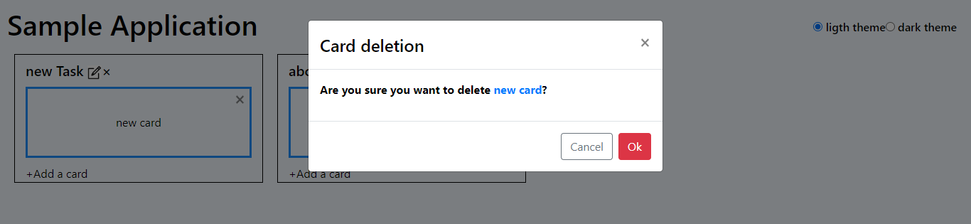

*Figure 7(b): card deleted*

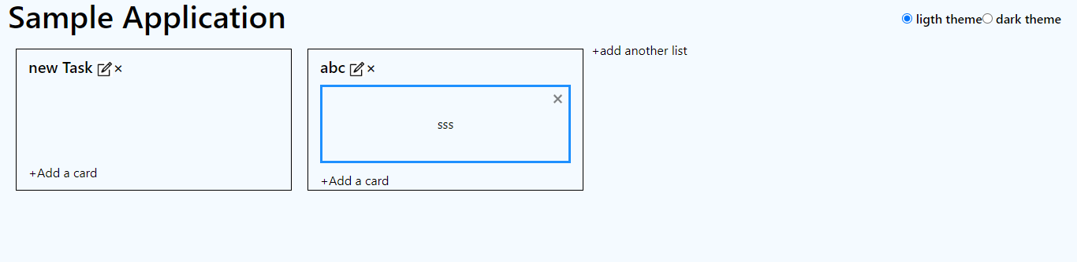

# **Confirmation Delete model for list**

After clicking cross button on list you get model for confirmation after clicking ok list is deleted

*Figure 8(a): list confirmation model for delete*

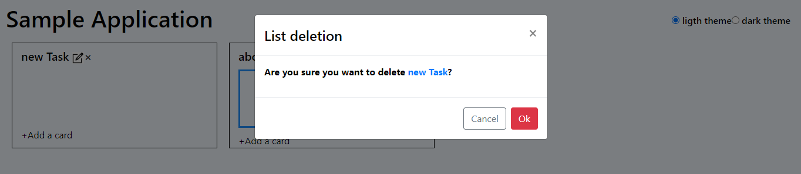

*Figure 8(b): list deleted*

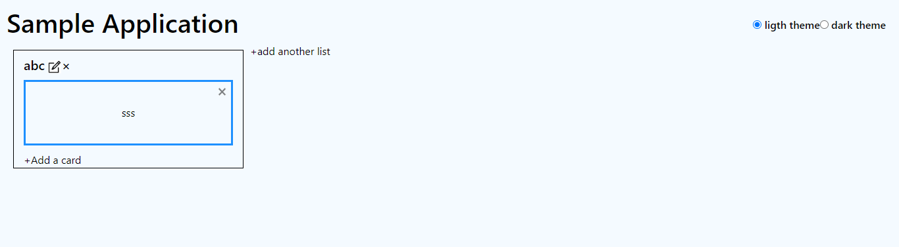

# **Edit list item**

On clicking list item cross edit popup opens

# **Approach**

1. In app list created blank list array which will hold all list and cards.
2. to add add list I pushed value to list array in add list model (getting list using @Input() decorator )
3. to add data to cards I passed current instance of list and pushed values to cards array key inside card model. (getting list using @Input() decorator )
4. to delete card I splice the current item from cards array inside current list item
5. to delete item I splice the current list item from list array
6. card item can be edited inline on clicking it
7. for edit list item edit model will open where we can edit it.
8. Created theme service to change theme using radio buttons